***Kearney Brothers Take Podium Places in Killarney***

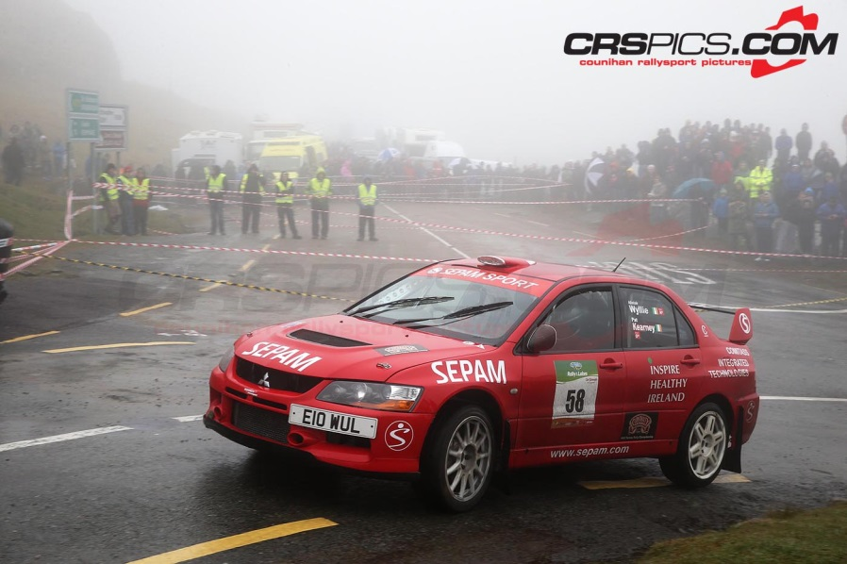

Pat Kearney and Alistair Wyllie on way to 2nd in Group N on Cartell.ie Rally of The Lakes (pic: Seamus Counihan)

Team Sepam Sport headed for the Kingdom for the Cartell.ie Rally of The Lakes; the 4th round of their Clonakilty Blackpudding Irish Tarmac Championship campaign. The event took the crews around stages surrounding the town of Killarney.

Following their Group N win on the Circuit of Ireland; Clonmel’s Pat Kearney and Rosscarbery’s Alistair Wyllie, were keen to repeat their good form in Kerry. Pat’s brother Gus, partnered by Tommy Hayes, was eager for a change of fortune and to get amogst the battle for the class, in their Gerry McGarrity Motorsport prepared Mitsubishi Lancer Evo 9s.

The class battle had added spice with return of Clonakilty’s David Guest, also equipped with a Mitsubishi. Following class wins in Galway and West Cork, the Cork man was clearly the man to beat, but also in the mix were the Subarus of Paul Barrett and Brian O Keeffe.

Day 1 took the crews across 8 stages. Pat and Gus drove at a steady pace on the morning stages, mindful of the tough nature of the event. A jump in pace in the afternoon saw Pat and Gus end the day in 3rd and 4th respectively, behind leader David Guest and Maynooth’s Paul Barrett in 2nd.

Day 2 brought the crews over such classic stages as Molls Gap, Ballaghbeama and Caragh Lake. Both Team Sepam crews were eager for a big attack, in particular; Gus Kearney. But cruelly, Gus and Tommy encountered electronic problems on the way to the first stage, causing a dramatic loss of power. It was now a case of survival and thinking of the championship, which they did in a character building 16th overall. Pat and Alistair inherited 2nd in Group following the retirement of Barrett on Molls Gap and 14th overall, with David Guest going on to take the Group N win.

The result sees Gus and Pat now lying in 2nd and 4th ,respectively, in Group N in the Clonakilty Blackpudding Irish Tarmac Championship on 48 and 30 points, with leader; Cork’s David Guest on 48 points, as the crews prepare to do battle again on the Joule Donegal International Rally in June.